S4 Identity Project

As the end of your high school career comes to a close... who have you become? Who are you? What do you identify with & who do you strive to be? This project will help you to come to the following conclusions, or help to make them known.

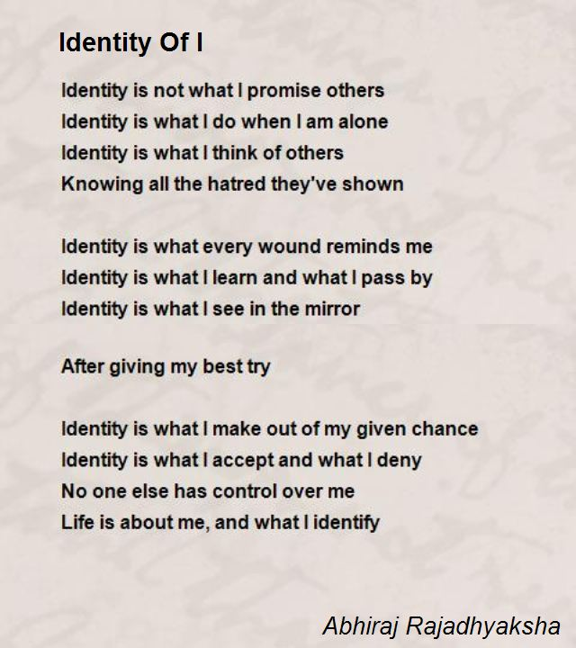

You will select 3 identity projects from the class website, and present them to the class in May as your final project in the course. The project will contain a product (three 25 point assignments = 75 pts) and a presentation grade (25 points each = 75 pts).

www.darrellenglish.weebly.com (to find detail about the projects)

- Bio Poem
- One Thing Photo Essay (Written)
- Graduation Speech (Written)
- Memory Letter (Written)
- 6 word memoir
- I’m From Essay (Written)
- I Believe… (25 – 30)
- Original Musical / Art Essay

- **Extra Credit**:

Identity all Bagged Up

One assignment must be a written document (2-3 pages) – MLA Formatted.

Due Date: May 20th / Presentations May 20th & 22nd
You will know your presentation date ahead of time. You may volunteer first, then random selection will take place.
- Only working on this project in class will not get the job done.
- DO NOT WAIT UNTIL THE LAST MINUTE
- AIM FOR 100%

Rubric for Written Pieces:
On Time 1 pt - Days late points will be deducted

 | Typed / Neat | MLA Formatted | Voice | Word / Page length | Grammar / Mechanics | Personal Connection
4
3
2
1-0

Rubric for Artistic Pieces:
1 pt on time – Days late points will be deducted

 | Color / Neat | # Requirement Followed | Personal Connection | Format followed
6
5-4
3-2
1-0

 | Color / Neat | # Requirement Followed | Personal Connection | Format followed
6
5-4
3-2
1-0

Presentation rubric:

 | 5 | 4 | 3 | 2 | 1-0
Content
Length Requirement/Format
Personal Connection
Style & Accuracy (Grammar/Errors)
Voice

Comments: ______________________________________________________________
_______________________________________________________________________________________________________________________________________________

