S3 Final Presentation/Product Assignment
Haikus!
To wrap up the 2019-2020 school year

- A form of poetry, first made popular in Japan, which has become appreciated around the world.

- Haiku poets are challenged to convey a vivid message in only 17 syllables.

- 5 – 7 – 5 syllables – Write a haiku about your feelings towards the end of the school year (your experience / the pandemic / social issues / etc.)

Due: Thursday (P4) and Friday (P7)
(You can submit earlier)
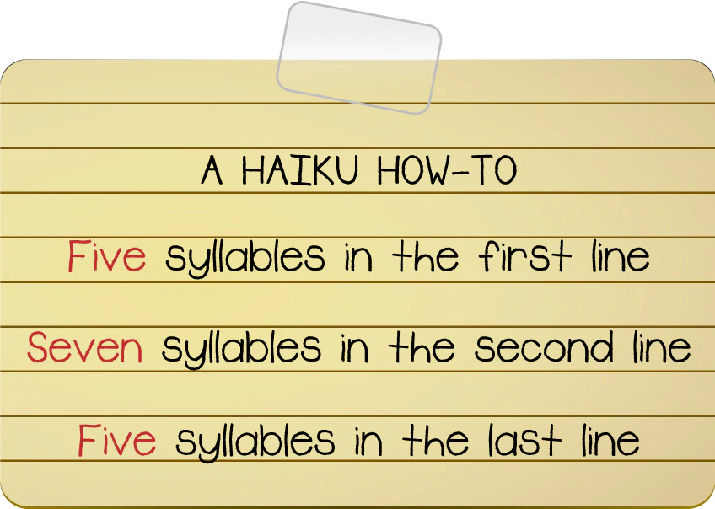

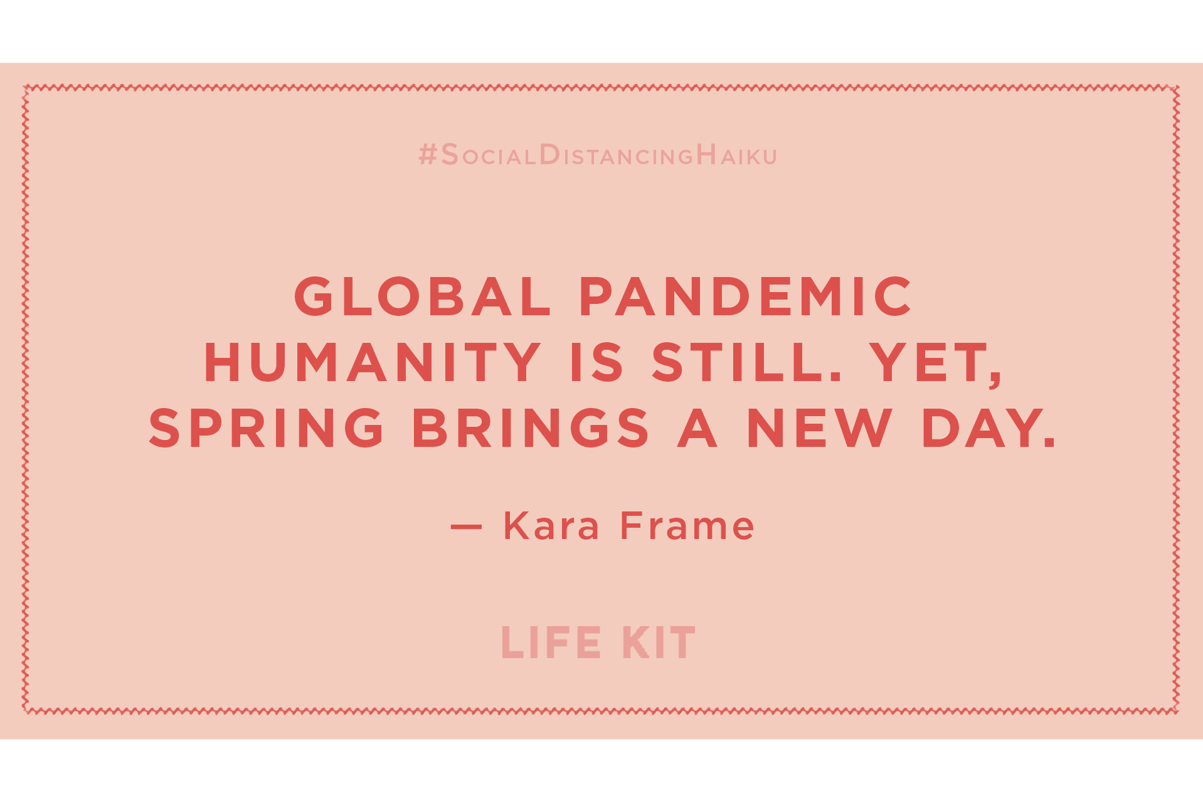
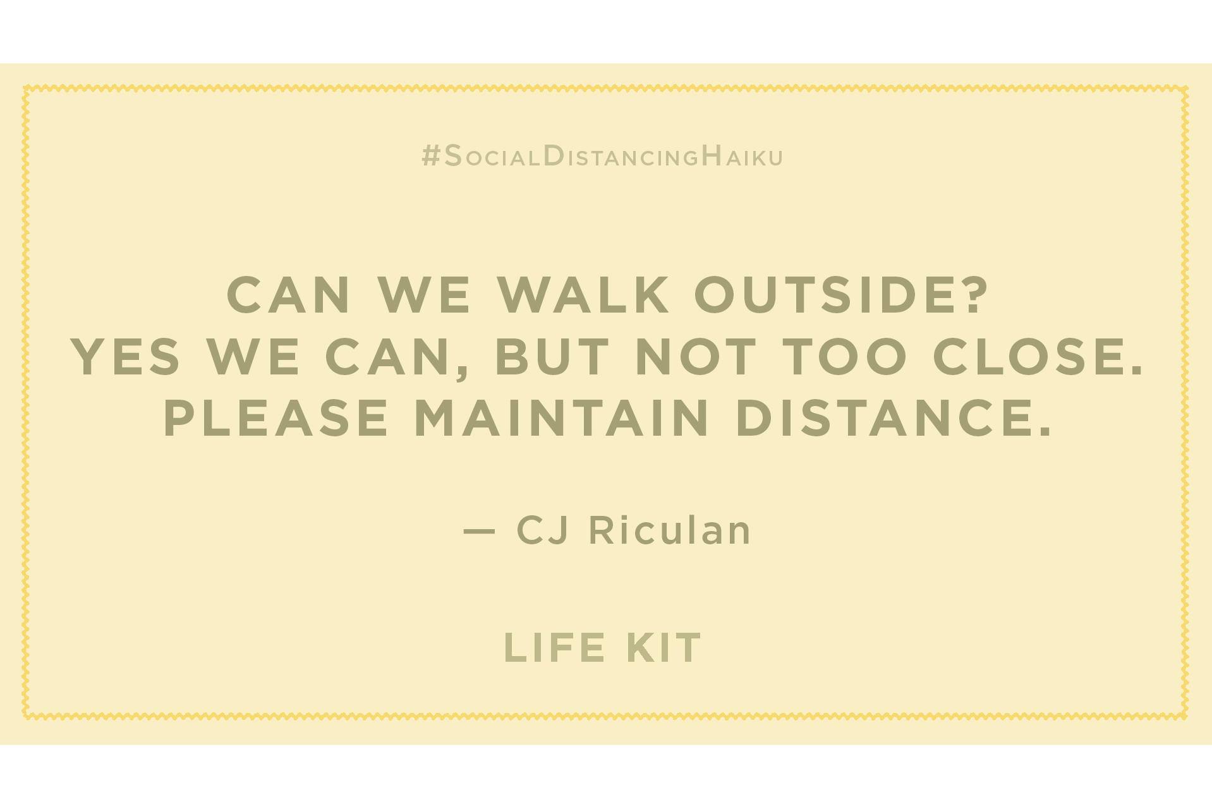

Product Rubric – 20 points
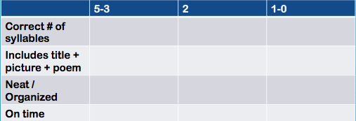

Presentation Rubric – 25 points

