S2 English Final Presentations (2)
Due Tuesday, June 9th – Thursday, June 11th

(Note- June 11th is the last day of class)

Topics:

- Pros & Cons of Remote Learning & Your Overall Experience (1-2 min)
- If you could change 1 thing in the world, what would it be (1-2 min)

Gradebook:
- 2 presentation grades (25 points each)
- 1 product grade (20 points)

Requirements:
  - Each (audio) presentation will include components of IGCSE descriptive, narrative, or persuasive aspects depending on how you choose to share
  - Provide a visual – a picture / a video / a quote

How to Prepare:
- Write notes / brainstorm
- Practice practice practice
- Time yourself
- Email your visual to khdarrell@berkeley.bm or kdarrell.edu@gmail.com
- You don’t have to write an essay

OPTION!
- You can pre-record yourself
- Upload to https://transfer.pcloud.com (email addresses above)

Product Rubric:
20 points - (1 entry)
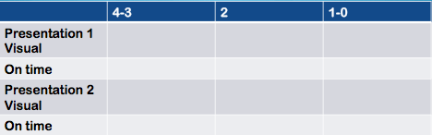

Presentation Rubric:
25 points – Topic 1 + 25 points – Topic 2 (2 entries)
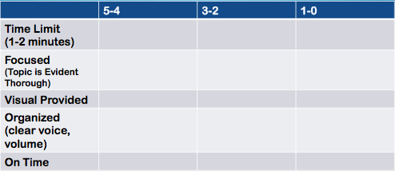

**You will receive 5 points extra credit if you present 1 or both presentations on Tuesday**

No late penalty until after Thursday, June 11th

