“Romeo & Juliet” Final Presentation
Due: Wednesday, June 10th

Select a quote about love. Explain the quote in 1-2 paragraphs and include a visual.
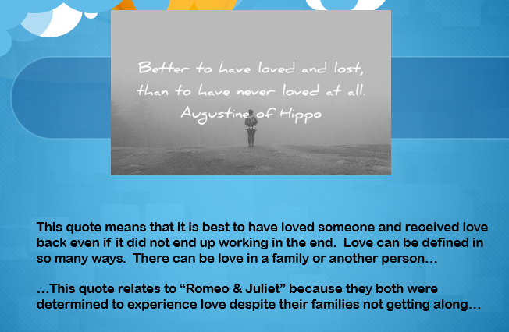

- Presentations will be Wednesday and Friday if necessary
- Presentations will be audio only unless you would like to be on video
- Send your visual + paragraphs to khdarrell@Berkeley.bm / kdarrell.edu@gmail.com

Option:
- You have the option of pre-recording yourself
- Please send the file to: https://transfer.pcloud.com/ - and use: khdarrell@berkeley.bm or kdarrell.edu@gmail.com
- DO NOT EMAIL A LARGE FILE PLEASE

Presentation Rubric (25 pts):
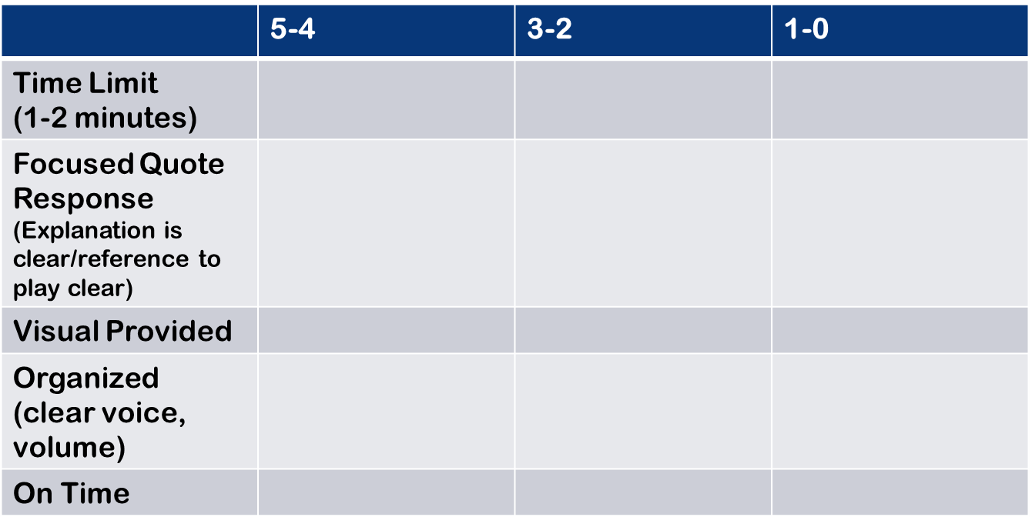

Product Rubric (20 pts):
