Personal Statement Assignment

Final Due: Friday, October 13th /Product Grade (40%)

Drafts Due: Friday, September 29th / Written Grade (20%)

Points Allotted: 25 points (15/25 passing --> 20/25 80%)

TASK: Write a personal statement that is
between 800-1000 words.

*All writing in this course & university will be in MLA format:
- Size 12
- Standard font (Calibri / Times New Roman)
- Double Spaced
- Headed with Name, Teacher, Class, Due Date/Date handed in

A "Personal Statement" - introduce yourself to a third party for a specific purpose (enrolling in a university, applying for a scholarship, seeking an internship opportunity, or applying for a job)

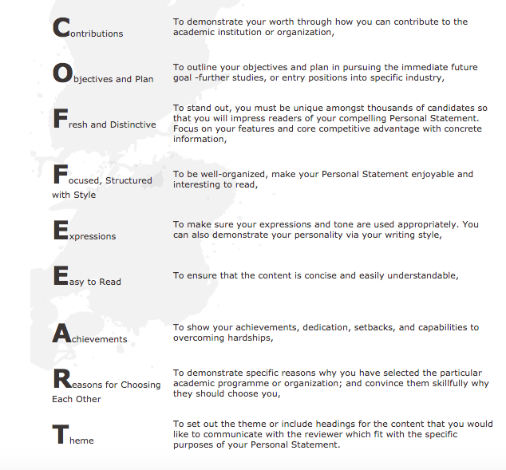

1. Make a list of the things you want the reader to know—and remember--about you. Try to be as concrete as possible. Ask yourself:
- What do I care about? Why?
- What questions motivate me?
- Where have my passions led me?
- What experiences have most shaped me?
- What is my most significant achievement?
- What do I hope to do in the future (education, career, etc.)?
- Now try to figure out your story: when you look at the list you have generated, is there a unifying theme? Is there a way of describing your path so far—regardless of whether it has been straight or winding—to show why applying for this scholarship is the logical next step?

- Start writing, allowing yourself plenty of time to rewrite. Your personal statement will probably go through more drafts than you can count. You may want to show it to a few close friends or mentors and ask for feedback. Writing your personal statement is an opportunity for reflection: you will likely learn about yourself during the writing process.

4. As you read what you have written, ask yourself the following questions:
- Is my writing clear and succinct? Am I avoiding unnecessary adverbs and adjectives, repetitive sentence construction, and the passive voice?
- Am I using concrete examples rather than vague generalities?
- Will the reader be confused at any point or left with unanswered questions?
- Am I writing for the educated reader who is not an expert in my particular field? (In most instances, this will be the right audience to have in mind.)
- Is my statement interesting? Will it hold the reader’s attention?
- Most importantly, is this personal statement an honest reflection of who I am?

