Steinbeck: Of Mice and Men:  Chapter Summary Chapter 1  We meet George and Lennie. They are American and live in the 1930s. Their job is to work and help on different big farms (ranches) to earn money.  Lennie is very big, tall and strong, but he is not clever and people laugh at him and are mean to him.  He is a grown man but sometimes he acts like a child. He loves to stroke soft things and keeps pet mice, even after they have died.  George is a small and clever man. He is Lennie’s friend; he looks after him and tries to keep him out of trouble. He tells Lennie, “Don’t do that!” if he thinks Lennie is going to do something wrong.  The story starts with the two men, who are planning to start a new job. They had to leave their old job in a different place, because Lennie got into some trouble there.  They have reached a quiet area between some trees and by the river (a clearing.) They are angry because they travelled on the bus to their new job and the bus driver stopped in the wrong place. So now they have a long way to walk and they are tired.  George tells Lennie not to speak at all to their new boss in case he thinks that he is stupid. They decide to sleep for the night in the clearing. They heat up  some beans to eat and they talk to each other. We learn about the trouble Lennie had in their old job. He had tried to touch a girl’s dress. He frightened her very much because she thought he was going to rape her. But really he just wanted to touch the soft material the dress was made from.  All the people in the town were very angry with Lennie and the friends had to hide and leave the area to look for a new job. The men talk about a special hope and dream they have: that they will one day buy a farm and live happily on it together. They plan to breed rabbits, which Lennie will look after.  Chapter 2  The next afternoon the two men arrive at the new ranch to start their job. They are to sleep in a “bunkhouse” with lots of beds. They meet an old man called Candy. He has lost his right hand in an accident. His job is to clean up and mop floors  (a “swamper”) He tells the men the boss is angry because they are late. But Candy says that most of the time he is quite a good boss.  The boss arrives to meet them and George explains  why they were late. The boss asks questions and writes down information about them. George answers for Lennie. The boss notices that Lennie doesn’t say anything. George says, “He doesn’t talk much but he’s as strong as a bull.” Lennie smiles and repeats, “Strong as a bull.”  The boss thinks that George is trying to control Lennie so that he can take some of Lennie’s money. George says this is not true- he tells the boss that he is looking after him because they are cousins and Lennie is not very bright.  When the boss has gone George is cross because he told Lennie that he was not supposed to say anything. But Lennie forgot this. They talk a little more and they realise that Candy has been listening to them and now he knows that they are not really cousins. But Candy promises not to tell anyone.  Just then the boss’s son, Curley, comes into the bunkhouse. He meets Lennie and George; immediately he does not like Lennie and he tries to fight with him. When he has gone, Candy tells them that Curley always hates big men like Lennie because he is so small himself. He warns them that Curly knows how to box and so he can be  dangerous.  Curley has recently got married and he seems to be more aggressive (he wants to fight more often) since then. George is worried about all of this and he thinks they might have trouble with Curley.  He tells Lennie that if he ever gets into trouble he should go back to the clearing by the river.  Curley’s new young wife comes into the bunkhouse and says she is looking for Curley. Lennie notices that she is very pretty.  After she has gone George warns Lennie to keep away from her because they do not want any more trouble. She could be a big problem for them if Lennie gets friendly with her.  Later they meet Slim. He is a skinner (driver of a mule team) on the ranch and everybody likes and respects him. Slim’s dog has just had puppies. Lennie is excited because he has always wanted his own pet.  The men talk about Candy’s old smelly dog and wish that he would get rid of it.  Chapter 3  George and Slim are talking in the bunkhouse. Slim has promised Lennie he can have one of the new puppies when it is older and Lennie is very excited.  They discuss how very strong and hard-working Lennie is. George tells Slim how he and Lennie came to be friends and travel around together. They are both from the same part of America and George knew Lennie’s Aunt Clara. When she died Lennie and George became good friends and began to spend their time together.  George describes how Lennie trusts him completely and will do anything he says. As an example he tells how once he told Lennie to jump in a river and Lennie did so, even though he couldn’t swim and he nearly drowned. Lennie comes into the bunkhouse – he is hiding the puppy which he is carrying, but George makes him carry it straight back to its mother.  Candy comes into the bunkhouse with his dog. Carlson complains about the smell of  the dog and offers to shoot it for Candy.  Candy does not want to kill the dog and makes excuses not to kill it- he has had the dog for a long time and maybe it would hurt him. Carlson says that he wouldn’t give the dog any pain. But he thinks that the dog is so old and sick that shooting it would be the kindest thing to do.  Candy then suggests they wait until tomorrow, but Carlson won’t agree and he takes the dog out to shoot him. Candy is very upset and says nothing- he lies on his bed staring (looking) at the ceiling. The other men are sorry and embarrassed- they play cards to move attention away from Candy.  Crooks, the Negro stable hand, looks inside the bunkhouse. He tells Slim that Lennie is handling the pups too much in the barn. Some of the men discuss going drinking and looking for women in town the next day. Curley comes into the bunkhouse. He is looking for his wife and is angry and aggressive. He goes out looking for Slim because he thinks Slim and his wife are together. George and Lennie keep well away from the trouble.  Lennie and George discuss their dreams of owning their own farm, living in a cosy (warm/comfortable) little house, growing vegetables and keeping pigs and rabbits. Candy hears their plans and asks if he can join them in the plan. He has money from when he lost his hand and some more savings. The other two men agree that he can join them in their big plan for the future. George will write to an old couple he knows who might want to sell their farm.  Curley and Slim enter the bunkhouse. Slim is angry that Curley keeps thinking he is with his wife- the other men join in and tell Curley he should keep his wife under control at home. Curley is angry and says Lennie is laughing at him. He attacks Lennie, who doesn’t fight back at first. But when George tells him to hit back at Curley, he takes Curley’s hand, squeezes it and crushes it very badly.  They have to take Curley to a doctor and they tell him he should say he caught his hand in a machine – if he tries to get Lennie into trouble, they will tell the full story and everyone will laugh at him.  squeezing and crushing a hand  Chapter 4  Crooks is in his room. He does not live with the other men because he is black. The other men are mean to him and say he stinks (smells). He has a lot of pain in his back and he rubs a cream into it to ease the pain. He likes reading and has some books and a dictionary in his room.  Lennie comes in, looking for someone to talk to. George and the other men have gone into town to visit women. At first Crooks is not very pleased at being disturbed, but he sees that Lennie is so simple that he can tell him whatever he likes and Lennie will not repeat or remember it.  Crooks teases Lennie, by suggesting that George might never get back from town and Lennie might never see him again. Lennie gets very worried and then angry - Crooks becomes frightened of Lennie in  this mood and quickly stops teasing him.  He tells Lennie how lonely he gets sometimes. Candy arrives, looking for Lennie; he comes into Crook’s room – something he has never done before. Candy and Lennie tell Crooks about their plans to have a farm of their own and keep rabbits. Crooks asks if maybe he could come and  live and work with them.  Curley’s wife appears and says she is looking for Curley, although she knows he has gone into town with the other men. The men tell her to go  away and leave them alone because she is trouble. She asks what has happened to Curley’s hand, they tell her that he caught it in a machine, but she doesn’t believe them.  She is very cruel to Crooks, and tells him that if she wanted to, she could have him hanged (by pretending he was trying to attack her). Candy tells her if she told stories like that the other men would tell the truth about her. She leaves the room and  George returns.  Chapter 5  Lennie is alone in the barn. It is Sunday afternoon and the other men are relaxing outside. Lennie is holding the dead puppy- he has killed it by accident. Now he is angry and worried that George will be angry with him. He thinks George won’t let him look after the rabbits when they get their farm.  Curley’s wife comes into the barn and begins to talk to Lennie. She sees the dead puppy and tells him not to worry about it. She tells Lennie that she does not like her husband; that she could have been an actress in films and have had an easy, happy life.  Lennie tells her he likes to touch soft things and she asks him to stroke her soft hair. He does this but he is too rough. She tries to pull away and this makes him frightened. They struggle and he kills her by accident. He runs away to the clearing.  Candy comes into the barn and finds the body. He brings George into the barn and shows him what has happened. George knows Lennie has killed her and they decide that the men will have to be told.  George and Candy will try to look after Lennie in any way they can. They know all their dreams of their own farm have gone.  Candy calls the men to tell them about the tragedy. Curley is very angry and he says he will go and find Lennie and shoot him. Carlson says his gun has been stolen. The men leave to find Lennie and George goes too. Candy stays with Curley’s wife.  Chapter 6  Lennie is waiting in the place (the clearing) where he and George slept before they started to work at the ranch. He is waiting for George. In his head he imagines his aunt Clara, who is angry with him for being such trouble to George.  Then he imagines a giant rabbit, who is laughing at him because he does not know how to look after rabbits.  George arrives and tells Lennie he is not mad at him. The voices of the other men can be heard. George thinks about the best way to help Lennie. He asks Lennie to sit with his back to him; George begins to tell him about their plans for the farm. Lennie loves to hear the story from George. George tells it in the same words he uses every time. Lennie asks if they can go now to their new farm. George says yes, they can go now.  While he is describing their farm and how happy they will be there, he quietly picks up the gun that was taken from Carlson. George tells Lennie to look hard into the distance; he might be able to see the farm they will go to. George’s hand is shaking. He brings the gun up to Lennie’s neck. He shoots him in the back of the head. Lennie falls slowly forward and lies still in the sand.  The other men arrive. They think Lennie must have stolen Carlson’s gun, which George had shot him with. Slim tells George there was nothing else he could do and he leads him away.  Curley and Carlson watch them walk away. They can’t understand why Slim and George are so sad.  THE END | 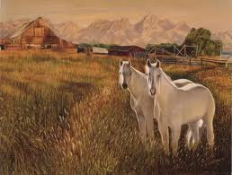  Ranch (farm)  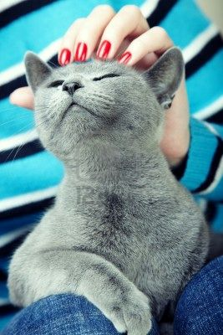stroking a cat  Clearing by a river  frightened girl  Dress materials  rabbits  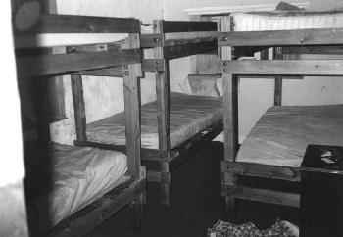  Bunkhouse  she has lost her right hand  Mopping the floor  bull  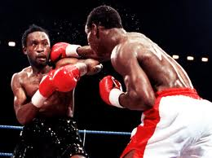  boxers  An aggressive man  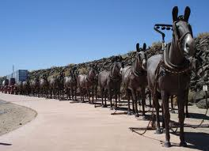  Mule team  puppies  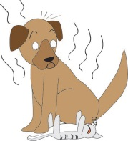  Smelly dog  Jumping into a river  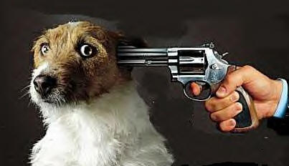  Shooting a dog  Staring at the ceiling  Playing cards  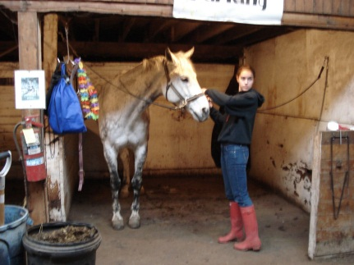  Stable hand  Cosy little house  old couple  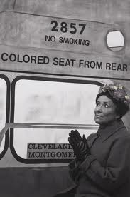  Black people suffered discrimination  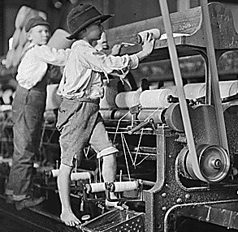  machine  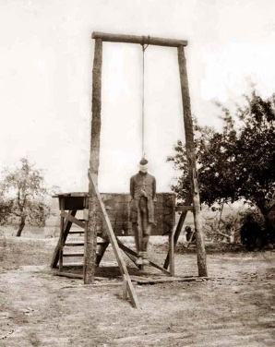  Punished by hanging  Pretending to be a doctor  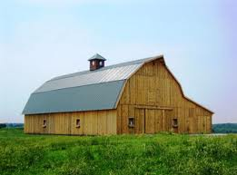  Barn  Actor and actress  Tragedies- floods/ deaths…  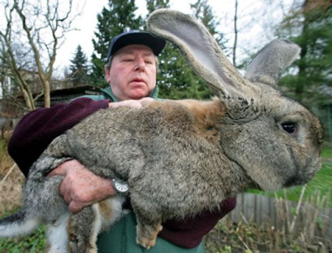  Giant rabbit  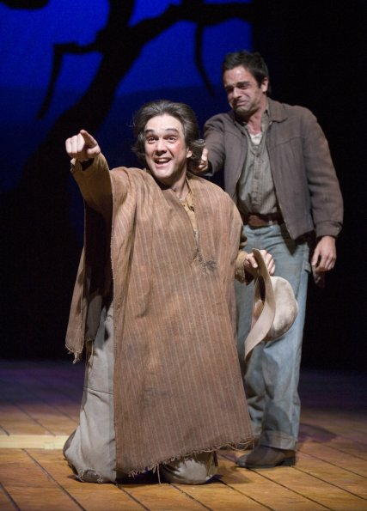  George shoots Lennie.

