Descriptive Writing Essay
UNIVERSITY OF CAMBRIDGE INTERNATIONAL EXAMINATIONS
International General Certificate of Secondary Education
Mrs. Darrell – S1 English

- Select the topic of your choice
- Fill in the graphic organizer to help you plan
- Type a 1 1-2 page rough draft to be handed in by Friday, June 3rd by the end of the day. (I will give feedback to drafts sent by Saturday)
  - www.darrellenglish.weebly.com (can be submitted here)
  - khdarrell@berkeley.bm (email for questions)
- Final paper with corrections will be due by the end of the day on Monday, June 6th
  - (will accept up until June 10th)
- Presentations are due Thursday, June 9th - Friday, June 10th
(unable to extend this)
++++++++++++++++++++++++++++++++++++++++++++++++++++++++++++++++++++++++++
Requirements:
- Write 1 – 1 ½ pages
- Size 12 – Calibri or Times New Roman.
- Double- Spaced
++++++++++++++++++++++++++++++++++++++++++++++++++++++++++++++++++++++++++
Tasks | Date | Gradebook Category | Points
Rough Draft | June 3rd | Written Grade | 20 points
Essay | June 6th | Product Grade | 25 points
Presentation | June 9th & 10th | Presentation Grade | 25 marks

Topics:
Think of your favorite place. What do you like about this place? What do you do there? How does it look, smell, and feel? Now write an essay describing your favorite place so that your reader will be able to picture it.
-OR-
Each season of the year is beautiful in some way. Think of which season is your favorite: winter, summer, spring or fall. Think of what your town looks like during that season. What does it feel like? Is there a smell or taste to it? Now write an essay describing an outdoor scene during your favorite season of the year.
-OR-
We all eat to stay alive, but everyone has a favorite food. What is your favorite food in the world? What does it look like? How does it smell and taste in your mouth? Describe your favorite food so that your reader can see it and almost taste it as well.

REMEMBER SHOW, DO NOT TELL
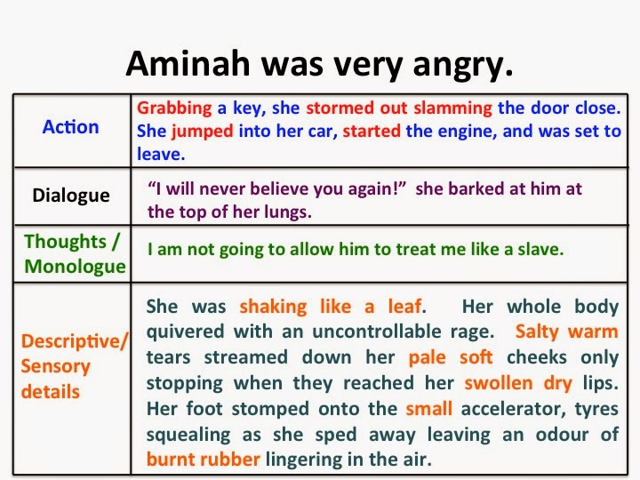

Parent Signature:___________________________________

