College / Career Readiness Presentation

Please create a PowerPoint presentation about our College / Career Readiness Assignments. Please include the following:
- A cover slide that includes the above title & your name - 2
  - If you know where you want to head after Berkeley, please include

- Your favorite paragraph from your Personal Statement -5

- A summary of your experience creating a personal statement (What did you learn about yourself, what did you learn about a P. S., what would you still change about your P.S.?) -5

- Visit 3 websites of businesses / universities –Write 3 tips that make an efficient resume -5

- Visit 3 college admission websites – Write 3 tips that make a winning personal statement that gains university entry -5

- Visit 3 scholarship websites – Write 3 tips that makes a winning scholarship application / letter -5

- Copy/paste the URLs from the various websites that you used on the last slide -5

Please include pictures & be aware of the size, font, & color of your presentation so that it is legible for all to see from the back of the classroom. -4
PowerPoint – 36 points (written grade)
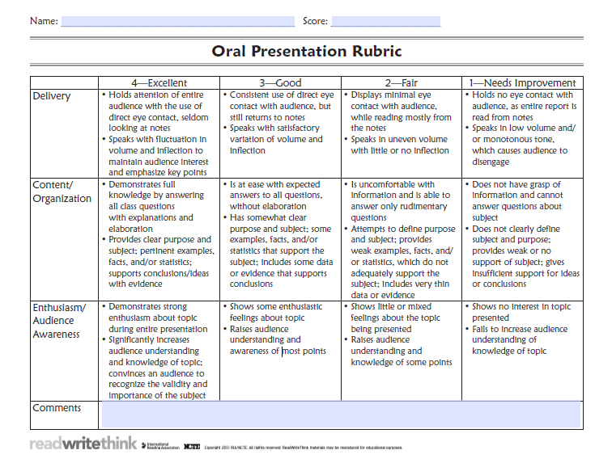
25 pt rubric
(1 pt allotted
for PowerPoint
Present)

