Option #1:
FAMILY AND THE AMERICAN DREAM ESSAY – THREE CHARACTERS. The family is the most important relationship in most people’s lives. Choose three of the main characters – Walter, Ruth, Beneatha, or Mama – and write a critical essay explaining how their experiences relate to the theme of family and the American Dream. In each body paragraph provide textual support (at last two quotes) that illustrate and explain what we learn about the family and the American Dream through that character. This means you will have three [3] body paragraphs that will each discuss a different character. Finally, in the conclusion discuss what one can learn about the relationship of family to the American Dream from the characters in the play.

Option #2:
Family Relations in Lorraine Hansberry’s A Raisin in the Sun:
How is the Younger family different from the traditional nuclear family? How are family dynamics depicted in the play? What causes conflict(s) within the Younger family? What conflicts are resolved by the end of the play, how, and by whom? What does the play say about familial relationships and responsibilities? Is responsibility to the self-deemed more or less important? What is the economic responsibility of each character? Who is the head of the Younger family?

Option #3:
Who is responsible for Walter's situation? Explain why.

Extra Credit Presentation: Create a Visual of your choice that includes your thesis, and main points of your essay. This must be presented to the class. (Presentation Grade 20%) 30 points.
Draft Due Date: Thursday, February 9th (Written Grade)
Final Due Date: Monday, Feburary 27th (Product Grade)

REQUIREMENTS:
· Your paper must be a complete argumentative essay.

· Your essay must contain an identifiable, complex, arguable thesis.

· Your argument should be based on a critical interpretation and close reading of the text(s). You should not spend significant time reporting or summarizing.

· You must use MLA style. (Size 12, double spaced, Calibri/Times New Roman)

· Your essay must meet the length requirement (3-4 pages).

· You must submit your essay at the beginning of class, on the due date.

· You must attach the Grading Criteria and all previous drafts to your essay.
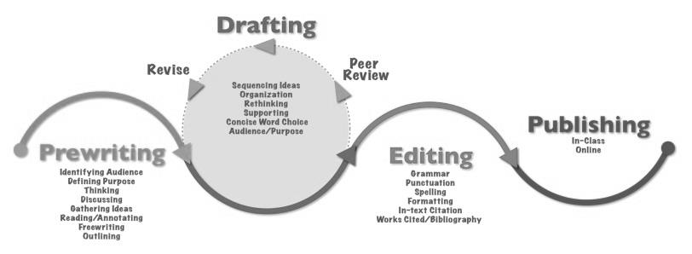
Example:
FAMILY THEME ESSAY
INTRODUCTORY PARAGRAPH
Opening hook sentences (2) – to get reader interest. Related to topic or theme, but
does not get into the specific details.
Development sentence – work in author and title.
Development sentence.
Development sentence.
Thesis – The importance of family can be clearly seen through the characters of
________, ________, and _________.

BODY PARAGRAPH ONE
Topic sentence – ________ shows the importance of ________.
Development – further explanation to make idea clear.
Development – into quote explanation.
Development – quote.
Development – comment on the quote, further clarifying idea.
Development – into quote explanation.
Development – quote.
Development – comment on the quote, further clarifying idea.
Transition – sentence tying this paragraph to the next one.

BODY PARAGRAPH TWO
Topic sentence – The character of _________ shows off a different aspect of family --
___________.
Development – further explanation to make idea clear.
Development – into quote explanation.
Development – quote.
Development – comment on the quote, further clarifying idea.
Development – into quote explanation.
Development – quote.
Development – comment on the quote, further clarifying idea.
Transition – sentence tying this paragraph to the next one.

BODY PARAGRAPH THREE
Topic sentence – Finally, the character of ________ shows off a different aspect of
family -- ___________.
Development – further explanation to make idea clear.
Development – into quote explanation.
Development – quote.
Development – comment on the quote, further clarifying idea.
Development – into quote explanation.
Development – quote.
Development – comment on the quote, further clarifying idea.
Transition – sentence tying this paragraph to the next one.

CONCLUDING PARAGRAPH
Thesis restated (in slightly different words) – The characters of _______, ______, and
________ show us ___________________. (Try to show how the values of the family
make the American Dream important.)
Development sentence – comment further.
Development sentence – apply play’s wisdom to life outside
Development sentence. of the play.
Clincher sentence – leave reader with powerful final thought.

